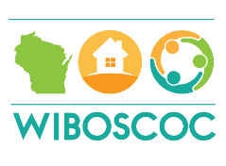

Youth Advisory Board Meeting
Stevens Point, WI Holiday Inn Convention Center
February 14, 2019

Welcome was made to the group. New Members introduced.
Attending: Meika-Family Services, Adam-Newcap, Lisa-Kenosha
All other members excused
Meeting was held after the Wisconsin Balance of State Meeting held in Stevens Point at the Holiday Inn Convention Center.
Introductions were completed. Adam is new to the group and was offered information about the group and how all of the pieces work. Discussion surrounding the Adult meetings and the Youth meetings were discussed. Information pertaining to the guidelines of 4 meetings per year with the youth and the thought of using go to meeting with some of the youth.
Discussed the mural idea and where we are in that process.
Discussed ideas of what other types of contests could be completed over the course of the year.
Discussed how to work with youth and strategies that have proven to be effective in the past.
Discussed RR Youth and how to navigate barriers
Discussed what Carrie may need from this group in the future
Next Meeting is to be determined (targeted for March)
Adjourned

