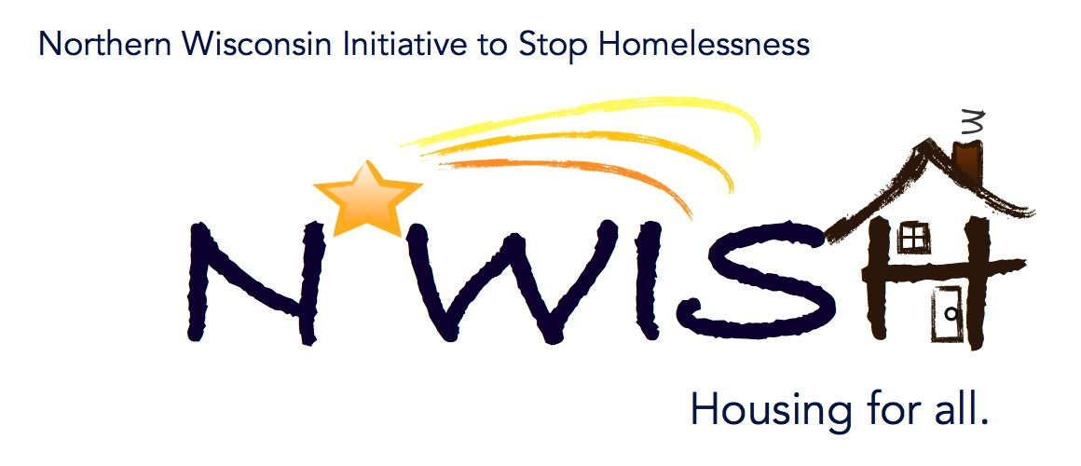
Northern Wisconsin Initiative to Stop Homelessness (N*WISH) Coalition
In-person or Via ZOOM
Zoom Link:
https://us02web.zoom.us/j/86798029037
51 N Brown Street, Rhinelander, WI
November 2, 2022
10:30 a.m. – 12:00 p.m.

Welcome/Introductions
Meaghan Gleason- Newcap
Aria Ard- Newcap
Karen Fish- Newcap
Makenna Kalata- Newcap
Emma Kowalewski- Newcap
Patsy Johnson- Newcap
Katie Stuckemeyer- School Social Worker at Northland Pines School District
Mark Martello, Iron Mountain VA Medical Center
Ashley Durand- Forward Service Corporation
Kaylee Chojnacki- CW Solutions
Debbie Meye - WDVA/VORP
Katey- Tri-County Council on DV/SA
Amanda Jahn- Salvation Army
Ginger Chroback- Rhinelander Food Pantry
Cassandra Robinson MSH Wisconsin
Mary John-Salvation Army
Dani Widdes - PATHS Housing Case Manager for young adults
Ashley Durand- Forward Service Corporation
Melissa Cornelius- AVAIL
Dani Widdes - PATHS
Taleka Dewing Food Pantry
Amanda Jahn- Salvation Army

October Minutes – VOTE
1st – Makenna Kalata
2nd – Melissa Cornelius

September Monthly PIT
Makenna shared NWISH Coalition Monthly Point-in-Time. 19 households in the NWISH area. Increase in homelessness compared to previous years. A lot of shelters are starting to fill back up. Lack of affordable rental properties in the area will most likely cause an increase in these numbers going forward.

YHDP “MOST” Project Update
We are still trying to find a vehicle for the mobile support team. It is difficult to find something that has the equipment to transport individuals. If anyone has any ideas on where to find an RV/Mobile Clinic, please reach out to Nicole.

YAB Update
There are currently three active members. They are still looking at possible places to meet in Antigo and/or Crandon. Must be available on a weekday from 6:30pm-7:30pm. The group identified that there is a need for someplace fun and safe for young adults to gather that does not serve alcohol. The YAB is looking to present at an upcoming meeting with their project that they have in mind!

Action Plan 4 – Update
Makenna Kalata
Makenna is working on reaching out to other agencies. She has also joined a Coordinated Entry committee which she plans on getting some ideas from. She is working on formulating some emails to meet with them in person, explain what coordinated entry is and why we do it If any agencies are interested in learning about coordinated entry, please reach out to Makenna.

Brainstorm – grants/programs needed in NWISH territory – any area
There is a huge need for affordable and available housing. Everyone is in agreeance that they are having a hard time transitioning individuals out of shelter due to lack of availability of housing. Application fees for rental units are also getting very high. One solution brought up was finding buildings, units, or schools that are currently sitting empty. There is also a lack of knowledge and/or apprehension from local landlords regarding programs.

EHH/ESG CARES CV Update
Housed: 1
Looking: 4
Currently pulling
Current barriers include lack of rental units, prior convictions, and lack of knowledge from landlords regarding programs.

Coordinated Entry Lead Update
Makenna Kalata
Newcap is the primary agency in NWISH completed coordinated entry. If anyone is thinking about adding coordinated entry to their agency, please reach out to Makenna at Makennakalata@newcap.org

DV Rapid Re-Housing Update
2 housed
1 unhoused

Balance of State Updates
The next quarterly meeting will be Friday, November 18th. Following several requests, the Board of Directors voted earlier this week to change the November quarterly meeting date (instead of Nov. 11th which is Veterans Day). To register, please visit: https://attendee.gotowebinar.com/register/7247294980928454413 At the November meeting, we will be seeking membership approval for the 2023 budget & dues recommendation.

Agency Updates, Future Presentations & Agenda Items
Forward services have seen an increase in need and those who have barriers, this could be due to winter and the holiday’s coming up. There is usually an increase during this time every year, but not to this extent.

Motion to Adjourn:
1st- Ginger Chroback
2nd – Makenna Kalata

Next N*WISH meeting
In-person or Via ZOOM
December 7, 2022 - 10:30 am – 12:00 pm

“We strive to host inclusive, accessible events that enable all individuals, including individuals with disabilities, to engage fully. To request an accommodation or for inquiries about accessibility, please contact Debbie Bushman, debbiebushman@newcap.org, 920-863-9402”

Please sign up for the Wisconsin Balance of State Newsletter www.wiboscoc.org, Home Page, click “Who are we?” to register

