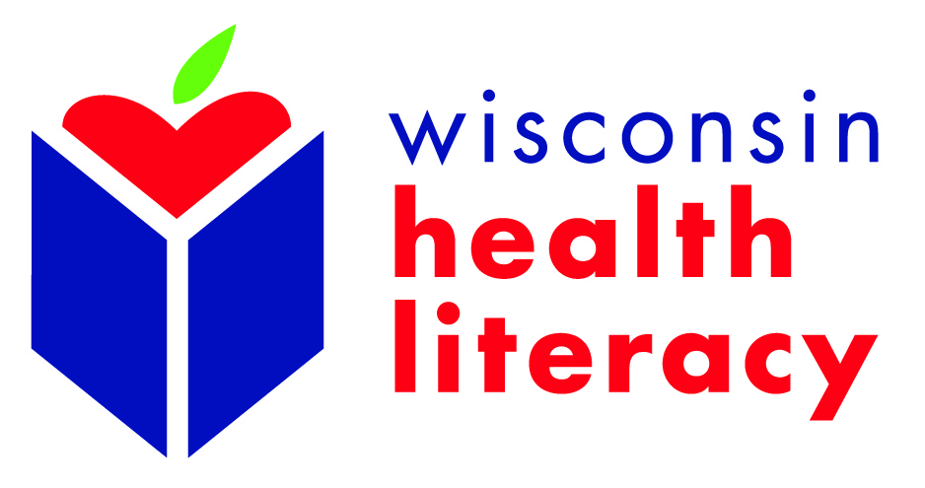

Project: “Let’s Talk About Pain Medicines” workshops
Project goals: To help adults (18 years and older) more safely and effectively use – and avoid the misuse of - prescription pain (opioid) medicine.
Length/Group size: 60 minutes; 10-30 participants
Participant Requirements:
- Adults
- 18 years or older

Project design: 60-minute interactive, hands-on workshops on how to more safely and effectively use prescription pain (opioid) medicine. Topics include:
- The differences between prescription opioids and other pain medicines
- Safe storage of opioid pain medicine to help prevent others from finding and using them
- What to do with unused opioid pain medicines (i.e.: where and how to get rid of them when no longer needed so they are out of the home)
- Understanding of label directions (when and how long to take the medicine)
- Special instructions on warning labels
- Illegality of using others’ medications
- When to call the pharmacist or provider
- History of opioids and the opioid crisis
- Use of naloxone and signs of opioid overdose
NOTE: The workshops are presented by non-clinical facilitators and are not intended to serve as medical advice.

Workshop incentives:
- $200 stipend for host organization (based on a minimum of 10 participants) to help cover potential costs: recruitment of participants, refreshments, staff time, refreshments, etc.
- Provide $50 if an interpreter outside your organization is needed during the workshop
- Participants receives a workbook, drug deactivation kit and other informational materials, including 4 fact sheets on:
  - How are prescription opioids and other pain medicines different?
  - How to keep opioids safe and how to get rid of unused medicines
  - What can go wrong when you use opioid medicines?
  - Opioid resources: treatment, recovery and community resources
    - Note: Titles/topics of fact sheets subject to change
- Participants can enter into a cash prize drawing at the end of the workshop

OVER

Partner Organization Responsibility:
- Designate staff person from your organization to serve as the site coordinator
- Recruit a minimum of 10 participants (recruit more in case some cancel)
- Host the workshop at your organization

Wisconsin Health Literacy Responsibilities:
- Facilitate the workshops
- Provide all workshop materials
- Conduct pre- and post-survey during the workshop

Workshops can be implemented throughout 2019 and sites will be selected on geographic location and date availability.

This project is supported by Security Health Plan

