Federal and State Moratorium on Evictions-Quick Sheet

Federal Eviction Moratorium

What is the Federal Eviction Moratorium?
It is part of the COVID Aid, Relief and Economic Security (CARES) Act. Eviction moratoriums are specifically addressed in Section 4024. It was signed into law March 27, 2020 and is in effect for 120 days, ending July 24, 2020.
What is covered under the federal eviction moratorium say?
Landlords:
  - Cannot evict for Non-payment of rent.
  - Cannot charge late fees, penalties or other charges related to non-payment of rent.
  - Cannot charge compounding interest on late fees that occurred before March 27, 2020.
  - Cannot give a notice to vacate during the moratorium.
  - Need to give a 30 day notice to the tenant after the moratorium ends before eviction can happen.
What is not covered under the federal eviction moratorium?
- Evictions filed before March 27, 2020.
- Eviction cases that involve properties that are not covered under the federal eviction moratorium.
- Eviction cases that are for anything other than non-payment of rent and nonpayment of fees or charges.
- No Cause evictions (month by month).
- The moratorium is not clear if cases of failure to renew a tenancy term are included in the moratorium.
- Rent is not waived. Tenants still owe rent, but they cannot be evicted for non-payment of rent during the dates of the moratorium.
Who does the federal eviction moratorium apply to?
For the moratorium to apply, the tenant must live in a unit covered by one of the following programs. There are four categories of housing programs:
A. Housing Programs covered under the Violence Against Women Act (VAWA) of 1994
Department of Housing & Urban Development (HUD) | Public Housing  Section 8 Housing Choice Vouchers  Section 8 Project Based Housing  Section 202 Housing for Elderly  Section 811 Housing for People with Disabilities  Section 236 Multi-Family Rental Housing  Section 211 (d)(3) Below Market Interest Rate (BMIR) Housing  HOME  Housing Opportunities for Persons with AIDS (HOPWA)  McKinney-Vento Act Homelessness Programs
Department of Agriculture | Section 515 Rural Rental Housing  Section 514 and 516 Farm Labor Housing  Section 533 Housing Preservation Grants  Section 538 Multi-Family Rental Housing
Department of Treasury | Low-Income Housing Tax Credit (LIHTC)

B. Rural Housing Voucher Program

The evictions moratorium also extends to “the rural housing voucher program under section 542 of the Housing Act of 1949 (42 U.S.C. 1490r).” Sec. 4024(a)(2)(A)(ii). The separate inclusion of this program was necessary because the Rural Housing Voucher Program was omitted from the covered housing programs in the 2013 VAWA reauthorization statute.

C. Properties with federally backed mortgage loans (FHA, Fannie Mae, Freddie Mac, USDA, VA loans) 1-4 units

Federally backed mortgage loans are defined to include loans secured by any lien on residential properties having 1-4 units and that are “made in whole or in part, or insured, guaranteed, supplemented, or assisted in any way, by any officer or agency of the Federal Government or under or in connection with a housing or urban development program administered by [HUD] or a housing or related program administered by any other such officer or agency, or is purchased or securitized by the Federal Home Loan Mortgage Corporation or the Federal National Mortgage Association.” Sec. 4024(a)(4).

Since tenants will often not have access to that information, advocates should assert that a landlord who files an eviction suit (for nonpayment of rent) during the federal moratorium period must plead and prove that the property is not subject to a federally backed mortgage loan.

D. Properties with federally backed multi-family mortgage loans (5 or more units)

A federally backed multifamily mortgage loan has the same definition as “federally-backed mortgage loan,” but is secured by a property with five or more dwelling units. See Sec. 4024(a)(5).

Is a Property Covered by the Federal Moratorium? The National Low Income Housing Coalition maintains a searchable database and map. NLIHC and the Public and Affordable Housing Research Service also maintain the National Housing Preservation Database. This is Fannie Mae’s Multifamily Loan Lookup Tool and this is Freddie Mac’s Multifamily Loan Lookup Tool. Katherine Khashimura Long of Seattle Times created a federally-backed multifamily mortgage loan finder with properties with Fannie Mae, Freddie Mac, or FHA multifamily mortgage loans as of March 2020.
Note: to access these links, press Control (CTRL) on your keyboard and left click the button on your mouse.

As a Housing Provider, what else should you know about the federal eviction moratorium?
- If a state has more protective moratorium, that will govern over the Federal. WI has a state eviction moratorium that covers more than what the Federal does.
- Agencies should be doing rent recertifications for clients who have lost their jobs or in a situation where household makeup has changed
- It can be confusing to determine what property might qualify if the tenant is not in a housing program. Here is a resource for determining if your client lives in a covered property
  - It is not an exhaustive list. http://nlihc.org/federal-moratorium
What are landlords allowed to do during this the federal eviction moratorium?
- Landlords can still send reminder notices about past due rent but may not send notices of eviction or charge fees.
- Try to collect fees that accrued prior to March 27th but they may not charge more fees and interest on those prior fees.
- Abandonment of a unit: A landlord must make a fact-based decision about whether a unit has been abandoned. A family may be quarantined with another family member so a landlord must take additional steps and document all steps taken to get in contact to assure that the unit has been in fact abandoned before moving forward with eviction proceedings. They cannot evict for no contact alone.
What if a landlord does serve an eviction notice during the federal eviction moratorium?
If a landlord serves your client an eviction notice, you should first verify that is not just a reminder of late or missing rent. If it is a true eviction notice, you should assist your client in getting legal assistance. Local courts may or may not be functioning right now, but it is illegal to evict someone during the moratorium.

Federal Eviction Moratorium Resources

CARES Act (Section 4024 is Temporary Moratorium on Eviction Filings) https://www.congress.gov/bill/116th-congress/house-bill/748/text?loclr=bloglaw#toc-H5FCB77F196104E7394A52A8F1DC5D1C2

DVHTAC COVID Special Topic-Eviction Moratorium. April 21, 2020 https://www.youtube.com/watch?v=pFU070T9ZY0&feature=youtu.be

HUD Office Hours April 17, 2020
https://www.hudexchange.info/trainings/courses/covid-19-planning-response-for-homeless-assistance-providers-office-hours-april-17/

HUD – Impact of Federal Eviction Moratorium on ESG and CoC-funded programs
https://files.hudexchange.info/resources/documents/Eviction-Moratorium-Impact-on-ESG-and-CoC-Programs.pdf

HUD - FAQs for Public Housing Agencies (April 21, 2020)
https://www.hud.gov/sites/dfiles/PIH/documents/PIH-HCV-Mod-Rehab-Eviction-QA.pdf

National Housing Law Project (NHLP) – Summary and Analysis of Federal CARES Act Eviction Moratorium (posted March 28, 2020; Updated April 28, 2020)
https://www.nhlp.org/wp-content/uploads/2020.03.27-NHLP-CARES-Act-Eviction-Moratorium-Summary.pdf

FAQ: Eligibility for Assistance Based on Immigration Status This fact sheet discusses eligibility under the CARES Act. NHLP also has this analysis about immigration requirements for ESG, CDBG, HOME, and FEMA assistance. (May 1, 2020)

National Low Income Housing Coalition (NLIHC) – Federal Eviction Moratorium, updated April 28, 2020. https://nlihc.org/federal-moratoriums
This searchable database and map allows some renters to identify if their home is covered by the CARES Act eviction moratoriums. These new tools contain data on millions of apartments in multifamily housing insured by the Federal Housing Administration or securitized by Fannie Mae or Freddie Mac, and millions more supported by the Low Income Housing Tax Credit, HUD, and/or USDA programs. The database and map are not comprehensive; they do not include data on single family rental homes of one to four units that are also protected under the CARES Act, and they do not include all Fannie Mae and Freddie Mac multifamily mortgages. When NLIHC obtains this additional data we will update the tools.

State Eviction Moratorium

What is the State eviction moratorium?
This was an Emergency order No. 15 signed into law by WI Governor Evers on March 27, 2020 and is in effect for 60 days until May 26, 2020.
What does the State eviction moratorium say?
- A landlord cannot evict for Non-payment of rent-all rental property is covered under this moratorium.
- Landlords are prohibited from serving any notice terminating a tenancy unless it is for an imminent threat of serious physical harm to another person. They would need to attach an affidavit stating that is the case.
- The moratorium covers all lease types.
- Sheriffs are banned from removing tenants from the premises unless it is for an imminent threat is serious physical harm to another person, even in situations where eviction filings happened before March 27th. Even in a case where the eviction was lost by a tenant and there is an eviction judgement, they cannot remove a tenant from their home during the moratorium.
- Mortgages cannot be foreclosed on, sheriffs cannot remove people from their houses or have a sheriff’s sale of mortgaged premises.
As a Housing Provider, what else should you know?
- Rent is not being waived. Tenants will still owe rent as usual, they just cannot be evicted for non-payment during the moratorium.
- Agencies should be doing rent recertifications for clients who have lost their jobs or in a situation where household makeup has changed.
- The state Public Service Commission has ordered Wisconsin utilities not to disconnect electric, heat or water service until the public health emergency has ended, and to work with customers who have been disconnected to restore service. WPS has extended the moratorium on shutting off utilities during the pandemic.
What are landlords allowed to do during this State eviction moratorium?
- Landlords can send notices about late or missed rent.
- If an eviction was filed prior to March 27, 2020, it may still go to court depending on the local courts. You would need to call your local clerk of courts to find out if the eviction is still going to court during this time.
- Landlords can give a termination notice if the landlord believes there is a threat of serious physical harm to another person if the tenant does not leave the rental property. They must attach an affidavit state that failing to evict that tenant will create a threat of serious physical harm to another person.
- Landlords can give eviction notices for the late or missing rent that accrued during the moratorium after the moratorium period.
Can fees or late penalties be charged?
No. On April 25, 2020 the WI Dept. of Agriculture, Trade and Consumer Protection (DATCP) finalized a temporary addition to ATCP 134.09: Prohibited Practices, that prohibits landlords from charging late fees for late payment of rent and/or nonpayment of rent until September 21, 2020.
What does this DATCP temporary addition mean?
ATCP Chapter 134 regulates the behavior of landlords towards tenants and Section 09 of the chapter, entitled Prohibited Practices, provides a list of activities and business practices landlords are not allowed to engage in under state law, ranging from renting condemned properties, retaliating against tenants for exercising their rights, and confiscating personal property. ATCP 134.09(8), entitled Late Rent Fees and Penalties, governs when landlords can charge tenants late fees. A brief review of this subsection reveals that landlords can:
(a) only charge late fees if the late fees are authorized in the lease agreement
(b)must first apply any money they receive from a tenant to currently due rent, and then to any other charges, such as late fees, that the tenant still owes, and
(c) cannot charge tenants late fees for late payment of late fees themselves.
EmR2002 adds a part (d) to that subsection so that it now also prohibits landlords from charging tenants late fees for late payment or nonpayment of rent during a statewide declared emergency and for 90 days following the end of that emergency.
This means that a landlord cannot a tenant a late fee if the tenant is late on their rent in May, June, July, August, or September of 2020. Any currently unpaid late fees (say from late payment of March's rent or April's rent) do not appear to be affected by this order, nor do late fees assessed after the order expires. This will likely mean that if a tenant is late on their October 2020 rent payment, their landlord will be able charge them a late fee, assuming the tenant's lease authorizes the landlord to do so.

Common Asked & Answered Questions
https://www.forwardlookout.com/2020/04/eviction-ban-updates-from-legal-action-of-wisconsin/31690

(1) How long is the ban in effect?
March 27, 2020 through May 26, 2020. The Governor could extend or change it.

(2) Do I still have to pay my rent?
Yes. The ban did not suspend rent payments.

(3) Can my landlord give me a termination notice?
Your landlord CANNOT legally give you a termination notice for nonpayment of rent, other minor lease violations, or a regular 28-day or 60-day notice for a month-to-month lease. A landlord CAN legally give a tenant a termination notice if the landlord believes there is a threat of serious physical harm to another person if the tenant does not leave the rental property. When a landlord gives this kind of termination notice, they must attach an affidavit stating that failing to evict that tenant will create a threat of serious physical harm to another person. Your landlord CAN issue termination notices after May 26, 2020 based on any rent you did not pay during the eviction ban.

(4) Can my landlord file an eviction case against me in court?
Your landlord can’t legally file a new eviction case in court through May 26, 2020, even if they already issued a termination notice, unless there is an imminent threat of serious physical harm to another person if you do not move. If your landlord files an eviction in court, they must include an affidavit swearing under oath that failing to evict you will create a threat of serious physical harm to another person. Your landlord can probably file a case in court after May 26, 2020 based on the old notice.

(5) What if I already lost my eviction case? Is the sheriff going to make me move?
Not during the ban. Sheriffs cannot remove you from your home even if an eviction judgment has already been issued by a court. There is an exception if your landlord tells the court that failing to evict you would put others in danger. After the ban is lifted, the sheriff will be able to remove you.

(6) Can my landlord evict me by locking me out or shutting off my utilities?
No. It is always illegal for your landlord to lock you out, shut off your utilities, or take any other threatening action to force you to move without a court order. If this happens, call your local police immediately and seek the advice of a lawyer.

State Eviction Moratorium Resources

Emergency Order #15 – Temporary Ban on Evictions and Foreclosures (March 27, 2020)
https://evers.wi.gov/Documents/COVID19/EO15BanonEvictionsandForeclosures.pdf

- Emergency Executive Order #15 states that, for the duration of the eviction moratorium, "landlords are prohibited from serving any notice terminating a tenancy for failure to pay rent" and are "prohibited from serving any notice terminating a tenancy unless the notice is accompanied by an affidavit attesting to the reasonable belief, and the basis thereof, that a failure to commence eviction proceedings will result in an imminent threat of serious physical harm to another person."
- Emergency Executive Order #15 also states that, for the duration of the order, "landlords are prohibited from commencing a civil action of eviction unless...the eviction action is not based on a failure to pay rent, and the judicial action seeking eviction is accompanied by an affidavit attesting that the eviction is not based on a failure to pay rent and to a reasonable belief, and basis thereof, that a failure to proceed with the eviction will result in an imminent threat of serious physical harm to another person."
- Emergency Executive Order #15 also states that, for the duration of the order, "Landlords may not deliver a writ of restitution to the sheriff, nor may the sheriff act on eviction orders unless...the eviction order was not based on a failure to pay rent, and the writ of restitution is accompanied by an affidavit attesting that the eviction is not based on a failure to pay rent and to a reasonable belief, and the basis thereof, that a failure to proceed with the eviction will result in an imminent threat of serious physical harm to another person."
WI Department of Agriculture, Trade and Consumer Protection (DATCP) – Emergency Rule Prohibiting Late Fees on Rentals (April 25, 2020)
https://d3n8a8pro7vhmx.cloudfront.net/tenantresourcecenter/pages/2578/attachments/original/1588616364/EmergencyRuleProhibitsLateFeesforRentals.pdf?1588616364

- Emergency Rule EmR2002: https://docs.legis.wisconsin.gov/code/emergency_rules/all/emr2002

- Rule Text, which modifies ATCP 134: https://docs.legis.wisconsin.gov/code/register/2020/772B/register/emr/emr2002_rule_text/emr2002_rule_text.

Legal Action of Wisconsin – Wisconsin’s 60-day Eviction Ban FAQ (April 6, 2020)
https://www.forwardlookout.com/wp-content/uploads/2020/04/Wisconsin-Eviction-Moratorium-FAQ.pdf
- Common Questions & Answers: https://www.forwardlookout.com/2020/04/eviction-ban-updates-from-legal-action-of-wisconsin/31690
- Youtube Video: https://youtu.be/IZsr5ARxm_w

Legal Assistance Resources in WI

In Wisconsin, there are 2 main legal assistance organizations: Legal Action of Wisconsin and Judicare.

Legal Action
Legal Action of WI website: https://www.legalaction.org
Here is a map of the Legal Action of Wisconsin service area:

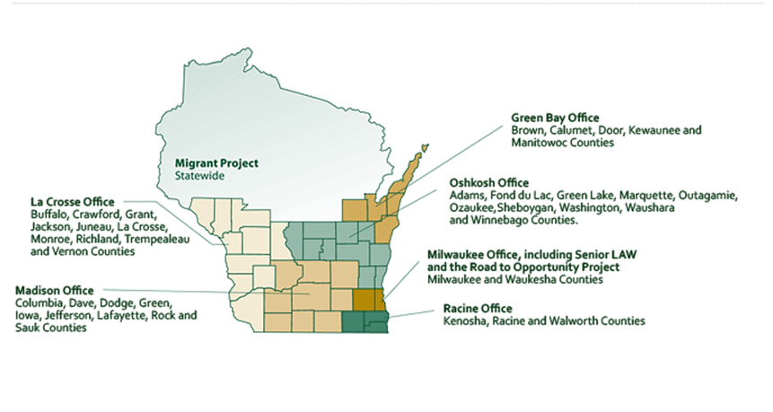
Each office has contact information, intake times, and serves specific counties. Note, things might be different at this time.
(1) Green Bay Office - 201 W. Walnut St, Suite 203, Green Bay WI 54303
Phone & Fax Numbers: 855-947-2529 (new caller/intake) 800-236-1127 (toll free)

(2) La Crosse Office - 205 5th Ave South Suite 300, La Crosse WI 54601
Phone & Fax Numbers: 855-947-2529 (new caller/intake) 800-873-0927 (toll free)
(3) Madison Office - 744 Williamson St, Suite 200, Madison WI 53703
Phone & Fax Numbers: 855-947-2529 (new caller/intake) 800-362-3904 (toll free)

(4) Milwaukee and Waukesha Office - 230 W. Wells St, Milwaukee WI 53203
Phone and Fax Numbers: 855-947-2529 (new caller/intake) 888-278-0633 (toll free)

(5) Oshkosh Office - 300 Ohio St, Oshkosh, WI 54902
Phone & Fax Numbers: 855-947-2529 (new caller/intake) 800-236-1128 (toll free)
(6) Racine Office - 4900 Spring St, Suite 100, Racine WI 53406
Phone & Fax Numbers: 855-947-2529 (new caller/intake) 800-242-5840 (toll free)
COVID Response Plan, changes: https://www.legalaction.org/contact-us/covid-19-coronavirus-response-plan

Judicare
The northern part of the state is covered by Judicare. http://www.judicare.org/
COVID Specific Page: http://www.judicare.org/Content/COVID-19FAQs.cfm
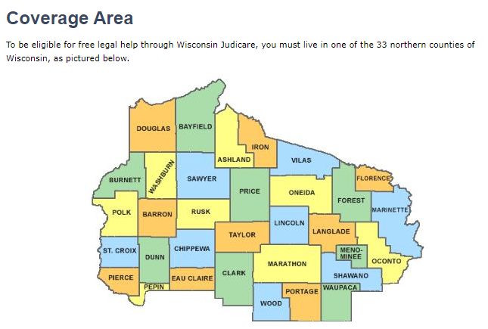
Physical Location - 401 Fifth St, Suite 200, Wausau WI 54403
Mailing Address - P.O. Box 6100, Wausau WI 54402-6100

How to Apply
If you are a resident of our service area or an enrolled tribal member, you are eligible to apply for Judicare services. You can:
- Apply online.
- Apply at one of our local outreach partners located in the northern 33 counties.
- Apply in person at our office.
- Apply over the phone.

**See highlighted Outreach Partner hyperlink to see alternative places to apply locally**

