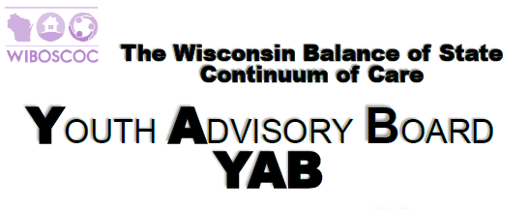
MONTHLY MEETING MINUTS
August 26, 2021

- Welcome and attendance Amy Fricke, Tanya Nelson, Beth Hudak, Patrick Duffie, Tara Prahl, Shannon Smith, Kennedy Kingston, Jaimee Ebert, Taylor Ahmed, Robin Adams, Leigh Polodna
  - Write was unable to take attendance for meeting. If there is an error, please let writer know
  - We need a new secretary. For today Jaimee Ebert took minutes, but we need a permanent note taker. Please let Cheryl, Tara or Melisa know if you are willing!
- There was a motion to approve agenda. Tanya approved, and Kennedy second.
- Today’s meeting was focused on the B.O.S. YHBP grant. First, Cheryl began with how to seek help from youth. It was stated that Newcap had gotten funds for a youth shelter, and asked for suggestions on how to get more shelters with the same mission, and that we could gain perspective from them once it opens. It was stated that agencies are pulling together to see how best to create a committee with including youth. In order to go forward with this, one of the first steps would be to contact these educated youth adults to talk about and discuss their stories and input regarding themselves experiencing homelessness. This would also be youth organized and lead. Kennedy brought up the idea of not only to get the youth support, but to also train the adults that will be apart of the committee and to learn from them, not to guess what would be best. Cheryl stated that there will be something put into place for youth to let the committee know what their needs are. Patrick brought up the point of what trainings would be best for the situation, and just wanted to make sure that the trainings would have everyone on the same page and making sure the youth are leading it. Meaghan also stated she think it’s a good idea to have this committee to have a clear direction, not changing ‘mid-stream’. These comments helped formulate a different purpose statement. Cheryl asked for approvals of the names of sections within the grant, and this was approved by committee and had no oppositions. It was also added the idea of training for technical assistance. For the 2021 goals and work plans, and clearly asked for a motion to accept the goals of the committee. This was approved. Leigh stated at this point in regard to youth, this is considered 24 and younger. The idea was brought up to think of content for social media to get the word out about the committee. Cheryl created a motion to adjourn, and it was accepted by the committee. The meeting ended at 300pm on August 26 and was confirmed of the next meeting on September 23 at 2PM.

