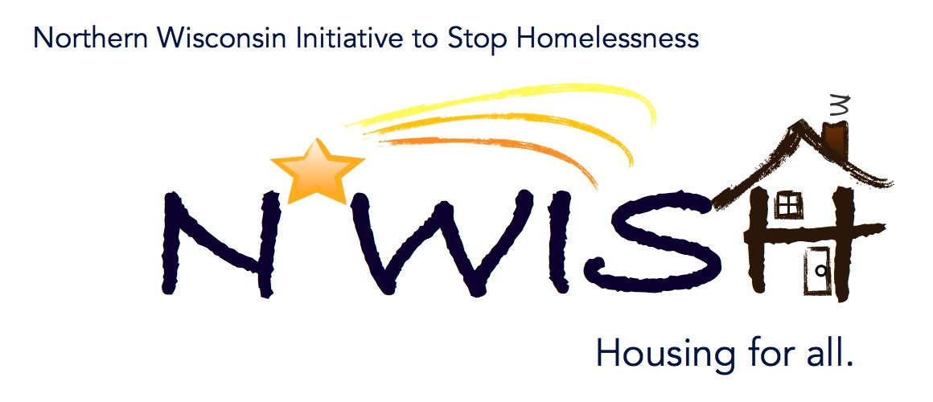
Northern Wisconsin Initiative to Stop Homelessness (N*WISH) Coalition
In-person or Via ZOOM
Zoom Link:
https://us02web.zoom.us/j/86798029037
51 N Brown Street, Rhinelander, WI
December 7, 2022
10:30 a.m. – 12:00 p.m.

Welcome/Introductions
Erika Villacrez- Newcap
Aria Ard- Newcap
Makenna Kalata- Newcap
Karen Fish- Newcap
Amanda Jahn- Salvation Army
Teleka Dewing
Katie Stuckmeyer- NPSD
Ginger Chrobak
Mark Martello
Holly Shampo- ADRC of the Northwoods
Beth Brunelli
Michael Basford- State of Wisconsin
Ashley Durand- Forward Service Corporation
Beth Brunelli- LMSW, Oscar Johnson VA

Debbie

November Minutes – VOTE
1st- Makenna Kalata
2nd- Debbie

October Monthly PIT and Upcoming PIT Count
Makenna shared the NWISH Coalition Monthly Point-in-Time count for October 2022. Shelters were full that month. Point-in-Time (also known as PIT) is done twice a year in the months of January and July on the fourth Wednesday night/ early Thursday morning. This count provides the numbers of unsheltered individuals. For the next week, agencies will also be collecting numbers of individuals who were unsheltered in places not meant for human habitation. Makenna is also working with the YAB on finding updated routes for the count. If you have ideas on places to search, connections with agencies who would like to participate, or even helping to get the word out about Point-in-Time please reach out to Makenna at makennakalata@newcap.org

YHDP “MOST” Project Update
We are in purchasing mode! We are looking at two different vendors one is in Littleton, Co and one is by Milwaukee. Someone will be going to check out the vendors and the units as soon as we can arrange travel. Hopefully we will either have the MOST Outreach vehicle in January! We have also received great feedback from the YAB for ideas on the logo and the graphics for the MOST vehicle.

YAB Update
At the most recent YAB meeting, they discussed the MOST vehicles and figuring out details regarding it. They are also putting together a formal presentation about the big brother/big sister program for youth who want to learn life skills. They also discussed the upcoming PIT count and where we should our routes to include any unsheltered youth.

Discussion on Future Action Plan Topics
Action plan 5 does not need to be completed just yet, although it was discussed that they would like to do something that includes DV.

EHH/ESG CARES CV Update
Continuing to search for housing to house the individuals who were pulled from the list. One individual is close to getting housing. We have 5 individuals that are currently searching, and no one housed. Challenges continue to be lack of affordable housing (not meeting fair market rent). Karen had found two new landlords who would like to work with Newcap. If you have landlord connections who would like to work with us, please let us know.

DV Rapid Re-Housing Update
4 housed, 1 unhoused. The individual who is unhoused as they do not want to live in another area and cannot rent with other large landlords in the area.
At Newcap, we currently have staff onboarding for this position.

Balance of State Updates
Agency Updates, Future Presentations & Agenda Items
BOS- today is the last day to register for the Shared Housing Training. It is a two-day workshop, beginning on
Amanda- Working on hot chocolate, trailer for upcoming events.
Newcap- Open interviews in Shawano. On Facebook page.
Mike Basford- Next month, Mike will be in Green Bay on the 25th for the Point-in-Time count. While in the area, he likes to visit with as many agencies as possible. Please email Mike at: mike.basford@wisconsin.gov if you are interested in having him at your agency!

Next N*WISH meeting
In-person or Via ZOOM
January 4, 2023 - 10:30 am – 12:00 pm

“We strive to host inclusive, accessible events that enable all individuals, including individuals with disabilities, to engage fully. To request an accommodation or for inquiries about accessibility, please contact Debbie Bushman, debbiebushman@newcap.org, 920-863-9402”

Please sign up for the Wisconsin Balance of State Newsletter www.wiboscoc.org, Home Page, click “Who are we?” to register

