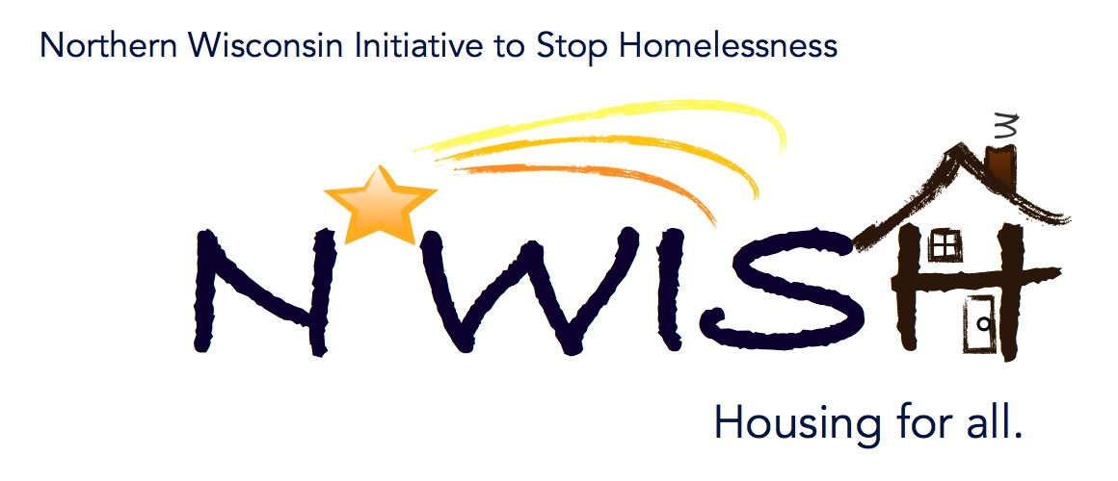

Northern Wisconsin Initiative to Stop Homelessness (N*WISH) Continuum of Care
Via ZOOM
Zoom Link:https://us02web.zoom.us/j/86798029037

October 7, 2020
10:30 a.m. – 12:00 p.m.
------------------------------------------------------------------------------------------------------------
Welcome/ Introductions

August and September minutes

August Monthly PIT

CoC Collaborative Application Discussion

Homelessness Prevention Update
Megan Cahill

EHH Update

Coordinated Entry Lead Update
Makenna Kalata

DV Rapid Re-Housing Update
Bobbi

Balance of State Updates
Michelle Arrowood

Agency Updates, Future Presentations & Agenda Items

Next N*WISH meeting
Northern Advantage Job Center/ZOOM
November 4, 2020 - 10:30 am – 12:00 pm

“We strive to host inclusive, accessible events that enable all individuals, including individuals with disabilities, to engage fully. To request an accommodation or for inquiries about accessibility, please contact Debbie Bushman, debbiebushman@newcap.org, 920-430-1350 ext. 1422.”

Please sign up for the Wisconsin Balance of State Newsletter www.wiboscoc.org, Home Page, click “Who are we?” to register

