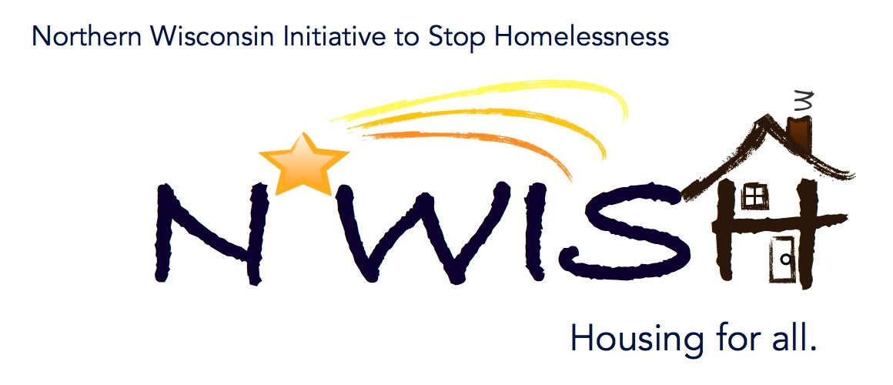
Northern Wisconsin Initiative to Stop Homelessness (N*WISH) Coalition
In-person or Via ZOOM
Zoom Link:
https://us02web.zoom.us/j/86798029037
51 N Brown Street, Rhinelander, WI
May 3, 2023
10:30 a.m. – 12:00 p.m.

Welcome/Introductions
Aria Ard – Newcap
Leigh Polodna – WIBOS
Katie Badeau – CW Solutions
Cassandra Robinson – MHS Wisconsin
Beth Larsen – CW Solutions
Karlie Merkel – Judicare
Teleka Dewing – Wasmogishek Food Pantry
Erika Villacrez – Newcap
Patsy Johnson-Haney – Newcap
Amanda Jahn – Salvation Army
Jennifer Allen – Institute for Community Alliances
Ashley Durand – Forward Services
Deanna Kloster – United Health Care Housing Manager
Breanna Stelson – CW Solutions
Breanna Beckwith – Tri-County Council – Rhinelander
Michael Basford – State of Wisconsin

April Minutes – VOTE
No motion, tabled until next month

March Monthly PIT
here is the link to data. https://docs.google.com/spreadsheets/d/1DwYZIaI_GKFfzYrx2jUuuBhqF6vEAKSnxdPI9pcqIfs/edit#gid=506165826
Makenna is working on putting together a data comparison of what trends we are seeing as far as shelter capacity being full and comparing to previous months/years and make sure it is easy to understand.

After Hours Plans - Revised – VOTE
Forest County After Hours Plan –
Motion to approve – Beth Larsen
Teleka Dewing 2nd
Langlade County After Hours Plan –
Motion to Approve – Amanda Jahn
Aria Ard 2nd
Oneida & Vilas Counties After Hours Plan –
Motion to Approve – Amanda Jahn
Beth Larsen 2nd

YAB Update
Plea to members to help promote membership for the YAB. The YAB is very important, it gives the Youth in our Communities a voice in the services that they need and they want. Please reach out to Meagan Gleason if you would like info on best practices for recruiting and or fliers to post. Her email is
YHDP “MOST” Project Update
We are waiting for quotes to come in for the wrapping of the vehicle, when that is done programming will start.

Tenant Protections for Domestic Violence Victims – Karlie Merkel, Legal Advocate Judicare Legal Aid

Karlie shared her thoughts regarding the legal information in order to educate our community members and service providers. She works for Judicare so the presentation was based on her thoughts on how the laws that she shared impact domestic violence survivors based on her work and experience.
Katie shared what domestic violence is, federal housing protections for Victims, Wisconsin Housing Protections for Victims, Common Housing issues Victims of Violence Still face, and Trauma – Informed Housing Assistance and Advocacy.
Karlie’s presentation was great.

Action Plan 2.0
Did not discuss at this meeting.

Coordinated Entry Lead Update

CE SSO update: if you have folks in shelter who have not spoken with CE to get on lists for CE please please, please have them follow up. We have been doing a lot of intakes in northeast counties since we are getting so many referrals from that area. We want to make sure NWISH folks are not falling through the cracks. If anyone has not yet contacted Newcap please have them contact our CE to set up a time to complete their intake. If needed we can set up a day at a local library or at shelter if there are residents who want to meet with in person. With DV shelters typically it is easier to do the local library for resident safety but both NewHope and Frederick has had no problems going in person to meet with folks who may prefer that. Any questions about CE or that process do not hesitate to reach out. As always if your agency would like to know more about how CE may be beneficial for the clients you work with, we are more than happy to do hands on training and/or get you the training videos and credentials to be able to complete and assess folks for our housing programs.

DV Rapid Re-Housing Update

Balance of State Updates – Leigh Polodna
Reminder the May 19th is the quarterly WIBOS meeting, here is the link to register:
For the business meeting, you must register at:
** https://attendee.gotowebinar.com/register/1775119072557029465
Leigh also reminded us that we currently do not have a WIBOS Board Member, which means that we currently have no one representing our NWISH Coalition at the Board Meetings. Please reach out to Erika or Nicole if you are interested in representing NWISH on the WIBOS Board.
HAP Information was sent out, it is now open to all agencies, you do not have to be a part of a COC to participate.

Agency Updates, Future Presentations & Agenda Items

Motion to Adjourn by Melissa, 2nd by Amanda. Meeting Adjourned

Next N*WISH meeting
In-person or Via ZOOM
June 7, 2023 - 10:30 am – 12:00 pm

“We strive to host inclusive, accessible events that enable all individuals, including individuals with disabilities, to engage fully. To request an accommodation or for inquiries about accessibility, please contact Debbie Bushman, debbiebushman@newcap.org, 920-863-9402”

Please sign up for the Wisconsin Balance of State Newsletter www.wiboscoc.org, Home Page, click “Who are we?” to register

