MINUTES
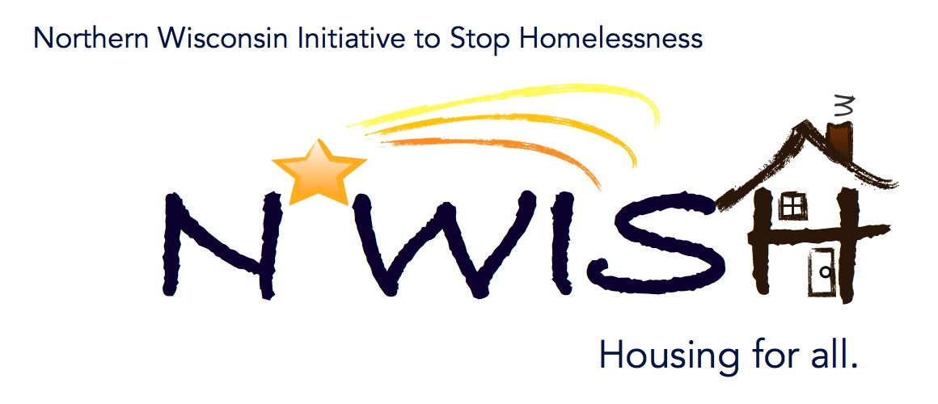
Northern Wisconsin Initiative to Stop Homelessness (N*WISH) Coalition
In-person or Via ZOOM
Zoom Link:
https://us02web.zoom.us/j/86798029037
51 N Brown Street, Rhinelander, WI
June 7, 2023
10:30 a.m. – 12:00 p.m.

Welcome/Introductions
Erin Evosevich - Newcao
Erika Villacrez – Newcap
Nicole Marchand – Newcap
Aria Ard – Newcap
Meaghan Gleason - Newcap
Micah Dewing – New Hope Shelter
Teleka Dewing Wasmogishek Food Pantry
Beth Larsen – CW Solutions
Ana Riggs – CW Solutions
Melissa Walsh – CW Solutions
Bobbi Braun – Forward Services
Debbie Meye – WI Department of Veterans Affairs
Jennifer Allen – ICA
Leigh Polodna – WIBOS
Michael Bashford – State of Wisconsin
Cassandra Robinson – MHS Wisconsin

April Minutes – VOTE
Motion to approve: Melissa CW Solutions
Second: Beth CW Solutions
All in favor

May Minutes – VOTE
Motion to approve: Melissa CW Solutions
Second: Beth Larson
All in favor

SSO CE Lead Agency – VOTE
Newcap is the only agency that came forward interested in the SSO CE Lead Agency,
Asked if any other agencies are interested in the Lead Agency, no one was interested
Motion to approve: Beth Larson
Second: Debbie Meye
All in Favor, Newcap will remain SSO CE Lead Agency for 2023-2024

April Monthly PIT
Emergency Shelter Utilization: Singles 39%, Families 74%
Transitional Housing Utilization: 50%, Families 0
Rapid Re-housing: Singles 33%, Families 25%

July Overnight PIT Count
This years overnight count will be the night of July 26 into the morning of July 27, 2023. Please reach out to housing@newcap.org. Melissa has been coordinating the Langlade area

Domestic Violence – What to watch for – Then what? – Postponed to next meeting
Melissa Cornelius

YAB Update – Meaghan Gleason
Taken time off over Memorial Weekend, still looking for more members. Invite young people to email Meaghan if they are interested in joining – meaghangleason@newcap.org. Meet every other Wednesday at 6:30. Paid $15 per hour. Currently have 3 core members and 1 person having a hard time getting time off. Summer would be a great time to get our young people involved.

YHDP “MOST” Project Update
Waiting for the wrap to be installed would like YAB approval, will follow up with Deb Barlament for the designs. Following up regarding a staff update.

Action Plan 2.0
Need to start thinking about part 1 DEI

Coordinated Entry Lead Update - Meaghan Gleason
800-242-7334
meaghangleason@newcap.org

DV Rapid Re-Housing Update
Currently we have two housed and two un-housed

Balance of State Updates
Leigh – YHDP Update – Leigh sent out an email regarding the renewal of the YHDP program for the 2024/2025 competition. More information will be coming out and meetings will be scheduled. End date of current programs will be 9/30/2024. Renewal will need to be worked on.
HAP Applications are due 6/16. Gearing up for competition will be receiving emails regarding the information.

Agency Updates, Future Presentations & Agenda Items
Newcap and CW Solutions were both awarded the Sex Trafficking Survivors and Caregivers Support Services funding.
CW Solutions REAP Program hired Ana Riggs as a new case manager, she will also be doing coordinated entry.

Motion to adjourn: Melissa Walsh
Second: Debbie Meye

Next N*WISH meeting
Via ZOOM
August 2, 2023 - 10:30 am – 12:00 pm

“We strive to host inclusive, accessible events that enable all individuals, including individuals with disabilities, to engage fully. To request an accommodation or for inquiries about accessibility, please contact Debbie Bushman, debbiebushman@newcap.org, 920-863-9402”

Please sign up for the Wisconsin Balance of State Newsletter www.wiboscoc.org, Home Page, click “Who are we?” to register

