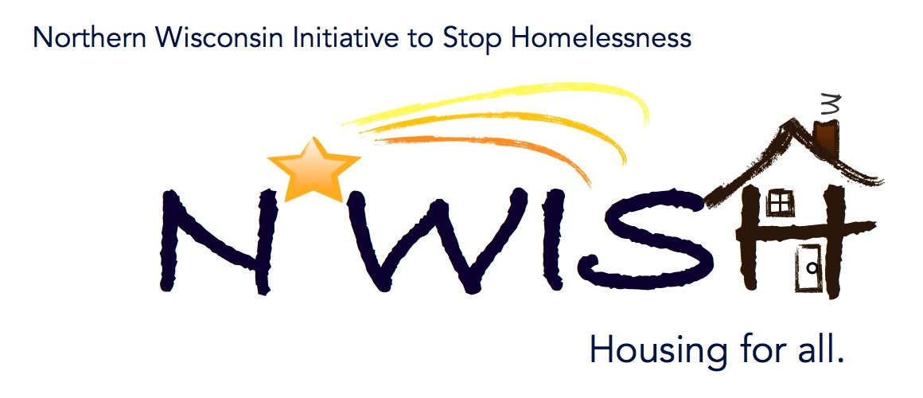
Northern Wisconsin Initiative to Stop Homelessness (N*WISH) Coalition
In-person or Via ZOOM
Zoom Link:
https://us02web.zoom.us/j/86798029037
51 N Brown Street, Rhinelander, WI
January 4, 2023
10:30 a.m. – 12:00 p.m.

Welcome/Introductions
Meaghan Gleason, Newcap
Nicole Marchand – Newcap
Erika Villacrez – Newcap
Makenna Kalata, Newcap
Patsy Johnson-Haney - Mental Health/AODA Counselor at Newcap
Karen Fish - Newcap
Mark Martello
Micah Dewing: New Hope Shelter
Michael Basford, State of Wisconsin
Breanna Beckwith
Tri County Council on DVSA in Rhinelander
Beth Larsen - CW Solutions
Debbie Meye WDVA - Veterans outreach and recovery- Region 5 Coordinator
Ginger Chrobak
Teleka Dewing, Wasmogishek Food Pantry, Crandon
Ashley Durand - W2 Program - Forward Service Corporation
Amanda Jahn, Salvation Army
Ashley Durand- FSC

December Minutes - VOTE
Due to the fact that the minutes were not sent out 24 hours in advance, the December minutes will be voted on at February’s meeting.

November Monthly PIT and Upcoming PIT Count
The PIT is a unique experience, we often forget the power of seeing literal homeless in person. The in-person PIT Count gives the Federal, State and local governments what our needs are and how we need to extend our service area and what we need to do differently to serve our literal homeless population. The more accurate count the more accurate data we get to see the real needs of our community. So in order to get a accurate count we need to make sure we are looking for the literal homeless in places we haven’t looked before parks, parking lots, storage units, etc, so we can get them housing for that night as well as get them signed up for the services that they need to be housed.
We are looking for at least one more volunteer team to do the PIT Count for the NWISH service area for the Southern part of Vilas County and Northern Oneida County. Please reach out to Makenna by January 15 so she can get the information out to the volunteers.

YHDP “MOST” Project Update
Good news we have a signed agreement with a company in Littleton Colorado to purchase our MOST Vehicle! Hopefully it will be ready for us to pick up in February. This is important so we can meet our homeless youth where they are at.

YAB Update
The YAB is very excited for the MOST to start, youth are very hesitant to walk into a building and ask for help. Being the MOST will meet the youth where they are at and feel safe, they feel is a real benefit.
Currently NWISH YAB has three core regular members but are always looking for more members, the board must maintain a 2/3 with lived experience. They welcome good conversation and would love to connect with other youth that may be interested in serving on the YAB. A reminder that this is a compensated role.
The YAB is interested in working with the MOST – How will it be marketed? What should it look like? Where should it go? Etc.
If you or your organization is interested in the YAB’s input on projects, questions please feel free to reach out to Meaghan @ meaghangleason@newcap.org and she will bring up the topic with the YAB.

Discussion on future action plan topics
Discussed at last meeting

EHH/ESG CV Update
Karen Fish
1 Housed has been looking for 6 months and after working the landlords Karen was able to get this family housed! Great job Karen! We sill have one looking for housing, but Karen will continue to work with landlords to see if she can make more progress. We are still pulling from the prioritization list as well, please refer if you have people that are in need of housing.

Coordinated Entry Lead Update
Makenna Kalata
Makenna is on the WIBOSCOC Coordinated Entry Committee – They are currently evaluating the whole process: what it looks like, how it works, referrals, how we can better serve those in need, how can we get more service providers involved with coordinated entry, etc. If you have any feedback on Coordinated Entry, please reach out to Makenna so she can report to the committee at makennakalata@newcap.org . Makenna will be reaching out to the NWISH Agencies to get those that are not currently working with Coordinated Entry. Even if organizations do not want to directly work with Coordinated Entry, if assessments can be filled out where clients are receiving services it will be a lot less invasive than to have to go thru their story again in a blind referral.

DV Rapid Re-Housing Update
Currently 2 Housed and 1 Unhoused, currently pulling. We did get an expansion to the funding, so we have two new staff members to work and pull more clients to bring them into programing. If you have landlords that would like to serve that population, please reach out to one of our staff members

Balance of State Updates
Next Quarterly BOS Meeting will be on February 10, more information will follow.

Agency Updates, Future Presentations & Agenda Items
Amanda Durand - W2 Agency – Numbers are going up, a lot of participants that are living in their vehicles, many with children. Clients are saying that there is a long wait for shelter. Erika mentioned that WERA is still available for rental assistance to help those with rental needs. Clients can go to one of our offices and have paperwork printed out so they can fill it out as well.

Interagency Council for Homelessness – Michael Bashford will be taking part in the PIT Count in Green Bay, please reach out to him if you would like him to stop in at your agency the next day. Veterans’ assistance with homelessness or housing insecurity can go to vrapwi.com for assistance.

Next N*WISH meeting
In-person or Via ZOOM
February 1, 2023 - 10:30 am – 12:00 pm

“We strive to host inclusive, accessible events that enable all individuals, including individuals with disabilities, to engage fully. To request an accommodation or for inquiries about accessibility, please contact Debbie Bushman, debbiebushman@newcap.org, 920-863-9402”

Please sign up for the Wisconsin Balance of State Newsletter www.wiboscoc.org, Home Page, click “Who are we?” to register

