Minutes
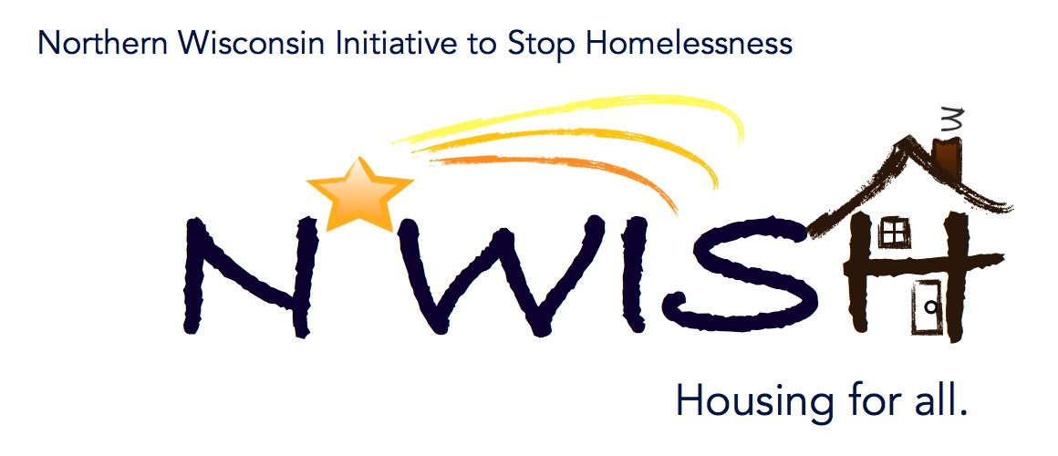
Northern Wisconsin Initiative to Stop Homelessness (N*WISH) Coalition
In-person or Via ZOOM
Zoom Link:
https://us02web.zoom.us/j/86798029037
51 N Brown Street, Rhinelander, WI
February 1, 2023
10:30 a.m. – 12:00 p.m.

Welcome/Introductions
Teleka Dewing – Wasmogishek Food Pantry
Karen Fish – Newcap
Nicole Marchand – Newcap
Makenna Kalata – Newcap – CE
Emma Kowalewski – Newcap
Meaghan Gleason – Newcap
Erika Villacrez – Newcap
Beth Larsen – PATH
Shannon Smith – AVAIL
Ginger Chrobak – Rhinelander Area Food Pantry / NATH
Amanda Jahn – Salvation Army
Beth Brunelli – VA Homeless Coordinator
Mark Martello – OGJVAMC
Leigh Polodna – WIBOSCOC
Michael Bashford – Interagency Counsel on Homelessness – State of Wisconsin

December Minutes – VOTE
Makenna – Motion to Approve – Meaghan 2nd

January Minutes – VOTE
Ginger - Motion to Approve - Makenna 2nd

December Monthly PIT
Makenna went over the numbers for the month – any questions please contact Makenna

January PIT Count Recap
Makenna reported that the PIT count went really well. We even had an extra team this year which allowed us to search areas that haven’t been searched in the past. At the time of this meeting one person was found and one person was observed. The post count surveys needed to be turned into her by February 1st. Karen tried something different this year, she went into businesses that are open 24-hours a day, for instance Kwik Trip, to get ideas where else to look other than the standard places. Makenna also posted more flyers in those businesses that are open 24-hours as well. The No Wrong Door Flyer will be sent out with these minutes so they can be re-distributed.

2023 Afterhours Plans – Review
It was decided that changes needed to be done to the plans to include: add CABA’s phone number for 24 hour afterhours calls, EHH information as well as revising the motel voucher information.

YHDP “MOST” Project Update
The new MOST Vehicle has been ordered and is complete. We are having someone fly out to pick it up in either late February or March.

WISBOS Back Up Delegate – VOTE
We voted to add a new back up delegate to vote on behalf of the coalition in Debbie Bushman’s absence at the WIBOSCOC meeting. A motion was made for Nicole Marchand to be that back up delegate by Karen Fish and 2nd by Beth Larson.

Action Plan 2.0
We went over the information from the WIBOSCOC regarding the Action Plan 2.0 with the group. Based on a conversation at a prior meeting it was decided that our 2nd Action Plan item would be the 4th goal that was listed in the hand out. We have a year to complete the action plan with an update in September halfway through the year.
Addressing needs of domestic violence, dating violence, sexual assault and stalking
Survivors. We chose component #2, because it seemed like a great place to start with this goal, educate the coalition and the community on both Trauma Informed and Victim-Centered approaches. Leah suggested that Golden House may be a good resource to get in touch with trainers for the safety training. Shannon from AVAIL also offered to help set up the training thru their contacts as well. Leah spoke briefly about he process and has been asked to be on the agenda for the next meeting to help us deep dive into our required goal which is Promoting Diversity, Equity, & Inclusion in Homeless Services.

YAB Update
The YAB is always looking for more Youth and Young Adults be part of the area YAB, this group is for the youth and about the youth. This group has a seat at the WIBOS an speaks for the youth. They meet every other Tuesday at 6:30 pm virtually as of now and are looking at planning events where they can meet up occasionally. One of their ideas that they have is to establish a program like Big Brothers/Big Sisters program that the mentors would continue to support them on their path to adulthood.

EHH Lead for 2023 – 2024 – VOTE
The only interested agency was Newcap.
Beth Larson made a motion that Newcap would remain the EHH Lead for the 2023 – 2024 year. It was 2nd by Amanda Jahn. Motion carried.
Newcap employees abstained from the vote.

Coordinated Entry Lead Update
Makenna Kalata
Makenna is working on sending out personalized emails to agencies to see about helping with the CE process getting them more involved with their clients possibly assisting them with paperwork, Vdatspadat and assessments, this way our client wouldn’t have to keep telling their stories over and over. The relationships they have built at the agency that they have contacts would probably keep them more at ease and more comfortable.

DV Rapid Re-Housing Update
1 housed, 1 unhoused
Un-housed is not returning contact + is unable to rent through most landlords in the city they want to be in – Rhinelander.

Balance of State Updates
Leah went over a list of trainings that are available. A new calendar on their website will have the trainings listed and will send them to a link to register for each training. Reminder the WIBOS quarterly meeting is on February 10, the board is pushing for a shorter meeting.

Agency Updates, Future Presentations & Agenda Items
Fredricks Place – Tammy is stepping down as the director, until a replacement can be found the team their will be jointly working on the director responsibilities. Tammy will be difficult to replace!
Tri County Director Shelly Holmes has retired as well.
Next month Leah with the WIBOS will be presenting on our Coalition’s DEI numbers and what it means to us as a part of our delve into our DEI Action Plan.

Next N*WISH meeting
In-person or Via ZOOM
March 1, 2023 - 10:30 am – 12:00 pm

“We strive to host inclusive, accessible events that enable all individuals, including individuals with disabilities, to engage fully. To request an accommodation or for inquiries about accessibility, please contact Debbie Bushman, debbiebushman@newcap.org, 920-863-9402”

Please sign up for the Wisconsin Balance of State Newsletter www.wiboscoc.org, Home Page, click “Who are we?” to register

