AGENDA
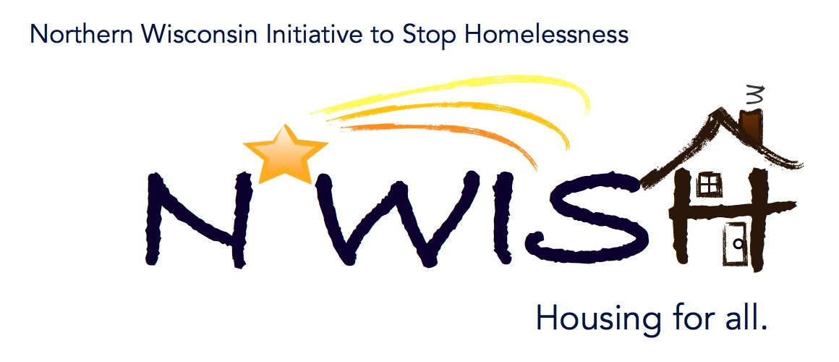
Northern Wisconsin Initiative to Stop Homelessness (N*WISH) Coalition
In-person or Via ZOOM
Zoom Link:
https://us02web.zoom.us/j/86798029037
51 N Brown Street, Rhinelander, WI
April 5, 2023
10:30 a.m. – 12:00 p.m.

Welcome/Introductions
Erin Evosevich- Newcap
Erika Villacrez- Newcap
Jennifer Allen- Institute for Community Alliances
Meaghan Gleason- Newcap
Michael Basford- State of Wisconsin
Teleka Dewing- Wasmogeshik Food Pantry
Mark Martello- Iron Mountain VA Medical Center Homeless Program
Breanna Stelson- CW Solutions
Ashley Durand- Forward Service Corporation
Makenna Kalata- Newcap
Michah Dewing- State of Wisconsin
Amanda Jahn- Salvation Army
Karen Fish- Newcap
Makenna Kalata- Newcap
Melissa Cornelius- AVAIL
Aria Ard- Newcap

March Minutes – VOTE
First- Meaghan Gleason
Second- Makenna Kalata

February Monthly PIT
Makenna states that everyone’s number for the February Monthly PIT are in with the exception of Lac Du Flambeau, who we have been trying to connect with. If anyone has a good contact phone number or email address, please let Makenna know.

After Hours Plans – VOTE
Oneida & Vilas County
First- Melissa Cornelius
Second- Makenna Kalata

Forest County
First Teleka Dewing
Second- Makenna Kalata

Langlade County
First- Makenna
Second- Melissa Cornelius

YAB Update
The last YAB meeting was a collaboration with the Northeast Youth Action Board. They shared ideas on what they want to work on and discuss in their own meetings. The youth also discussed how they can get more engagement and participation from agencies in their area to get more youth on the YAB. If you have any youth or questions regarding the YAB, please contact Makenna at makennakalata@newcap.org

YHDP “MOST” Project Update
We currently have the YHDP Most Project truck for the outreach clinic! Erika shared a video tour of the truck that is currently located at our Shawano location.

Melissa Cornelius – Avail
AVAIL is a domestic violence and sexual abuse agency. They have five bedrooms and can serve up to five families at a time. They don’t ask families to share their bedrooms with other residents during their stay. Beyond shelter, AVAIL works with clients on an on-call basis. There is a staff member in the building 24/7 as well as a staff member on their crisis line 24/7. The maximum length of stay goes on a case by case basis although their average stay is around 90 to 120 days. They are also able to assist with the entire process of a restraining order. They do a lot of outreach with schools, and they have had a lot of success with Antigo High School, which they are currently spending two days a week in their classrooms. They are also trying to do outreach with other schools in the area as well. AVAIL also offers support groups, but these have struggled post covid as internet options weren’t very successful. If you know anyone who would like to attend one of the support groups at AVAIL, please let them know beforehand as they like to go over a few things prior to the group starting. Flyers for these support groups will be sent in an upcoming email.

Action Plan 2.0
One goal of the Action Plan was to get more domestic violence partners at the table, such as AVAIL. We are also hoping to get other victim service providers to join us as well. If local providers are unable to provide training, there is an End Abuse Training. They have many different trainings available such as trauma informed care, safety planning, risk assessment, and Foundations for Advocacy which covers pieces on a lot of different topics.

Coordinated Entry Lead Update
Makenna Kalata
Makenna states there is not a ton of updates also she is working on developing a case conferencing group specifically for NWISH. This is for folks who are more towards the bottom of the list. This group would try and find options and solutions to try and get them out of the homeless system. If you are interested in participating or if you or your agency is interested in learning more about the coordinated entry process, please contact Makenna at makennakalata@newcap.org.

DV Rapid Re-Housing Update
DV Rapid: We are currently pulling a lot of individuals. If you have clients who are fleeing or attempting to flee, please let us know. We have one household housed and we have one household that is currently looking for housing.
EHH: One household is housed and one housing is looking for housing.

Balance of State Updates

Makenna motion to adjourn, Melissa seconds
Agency Updates, Future Presentations & Agenda Items
Michael Basford, State of Wisconsin- Mike will be stopping by agencies in our area. If you would like Mike to stop by your agency email mike.basford@wisconsin.gov

Next N*WISH meeting
In-person or Via ZOOM
May 3, 2023 - 10:30 am – 12:00 pm

“We strive to host inclusive, accessible events that enable all individuals, including individuals with disabilities, to engage fully. To request an accommodation or for inquiries about accessibility, please contact Debbie Bushman, debbiebushman@newcap.org, 920-863-9402”

Please sign up for the Wisconsin Balance of State Newsletter www.wiboscoc.org, Home Page, click “Who are we?” to register

